For Release March 13, 2020
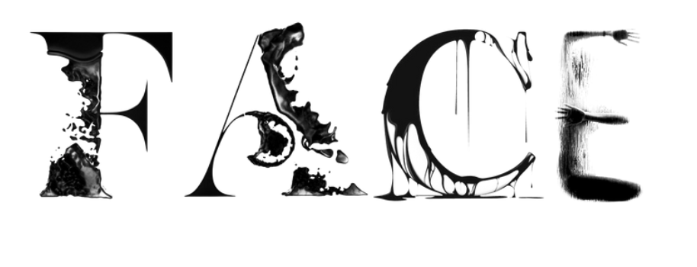
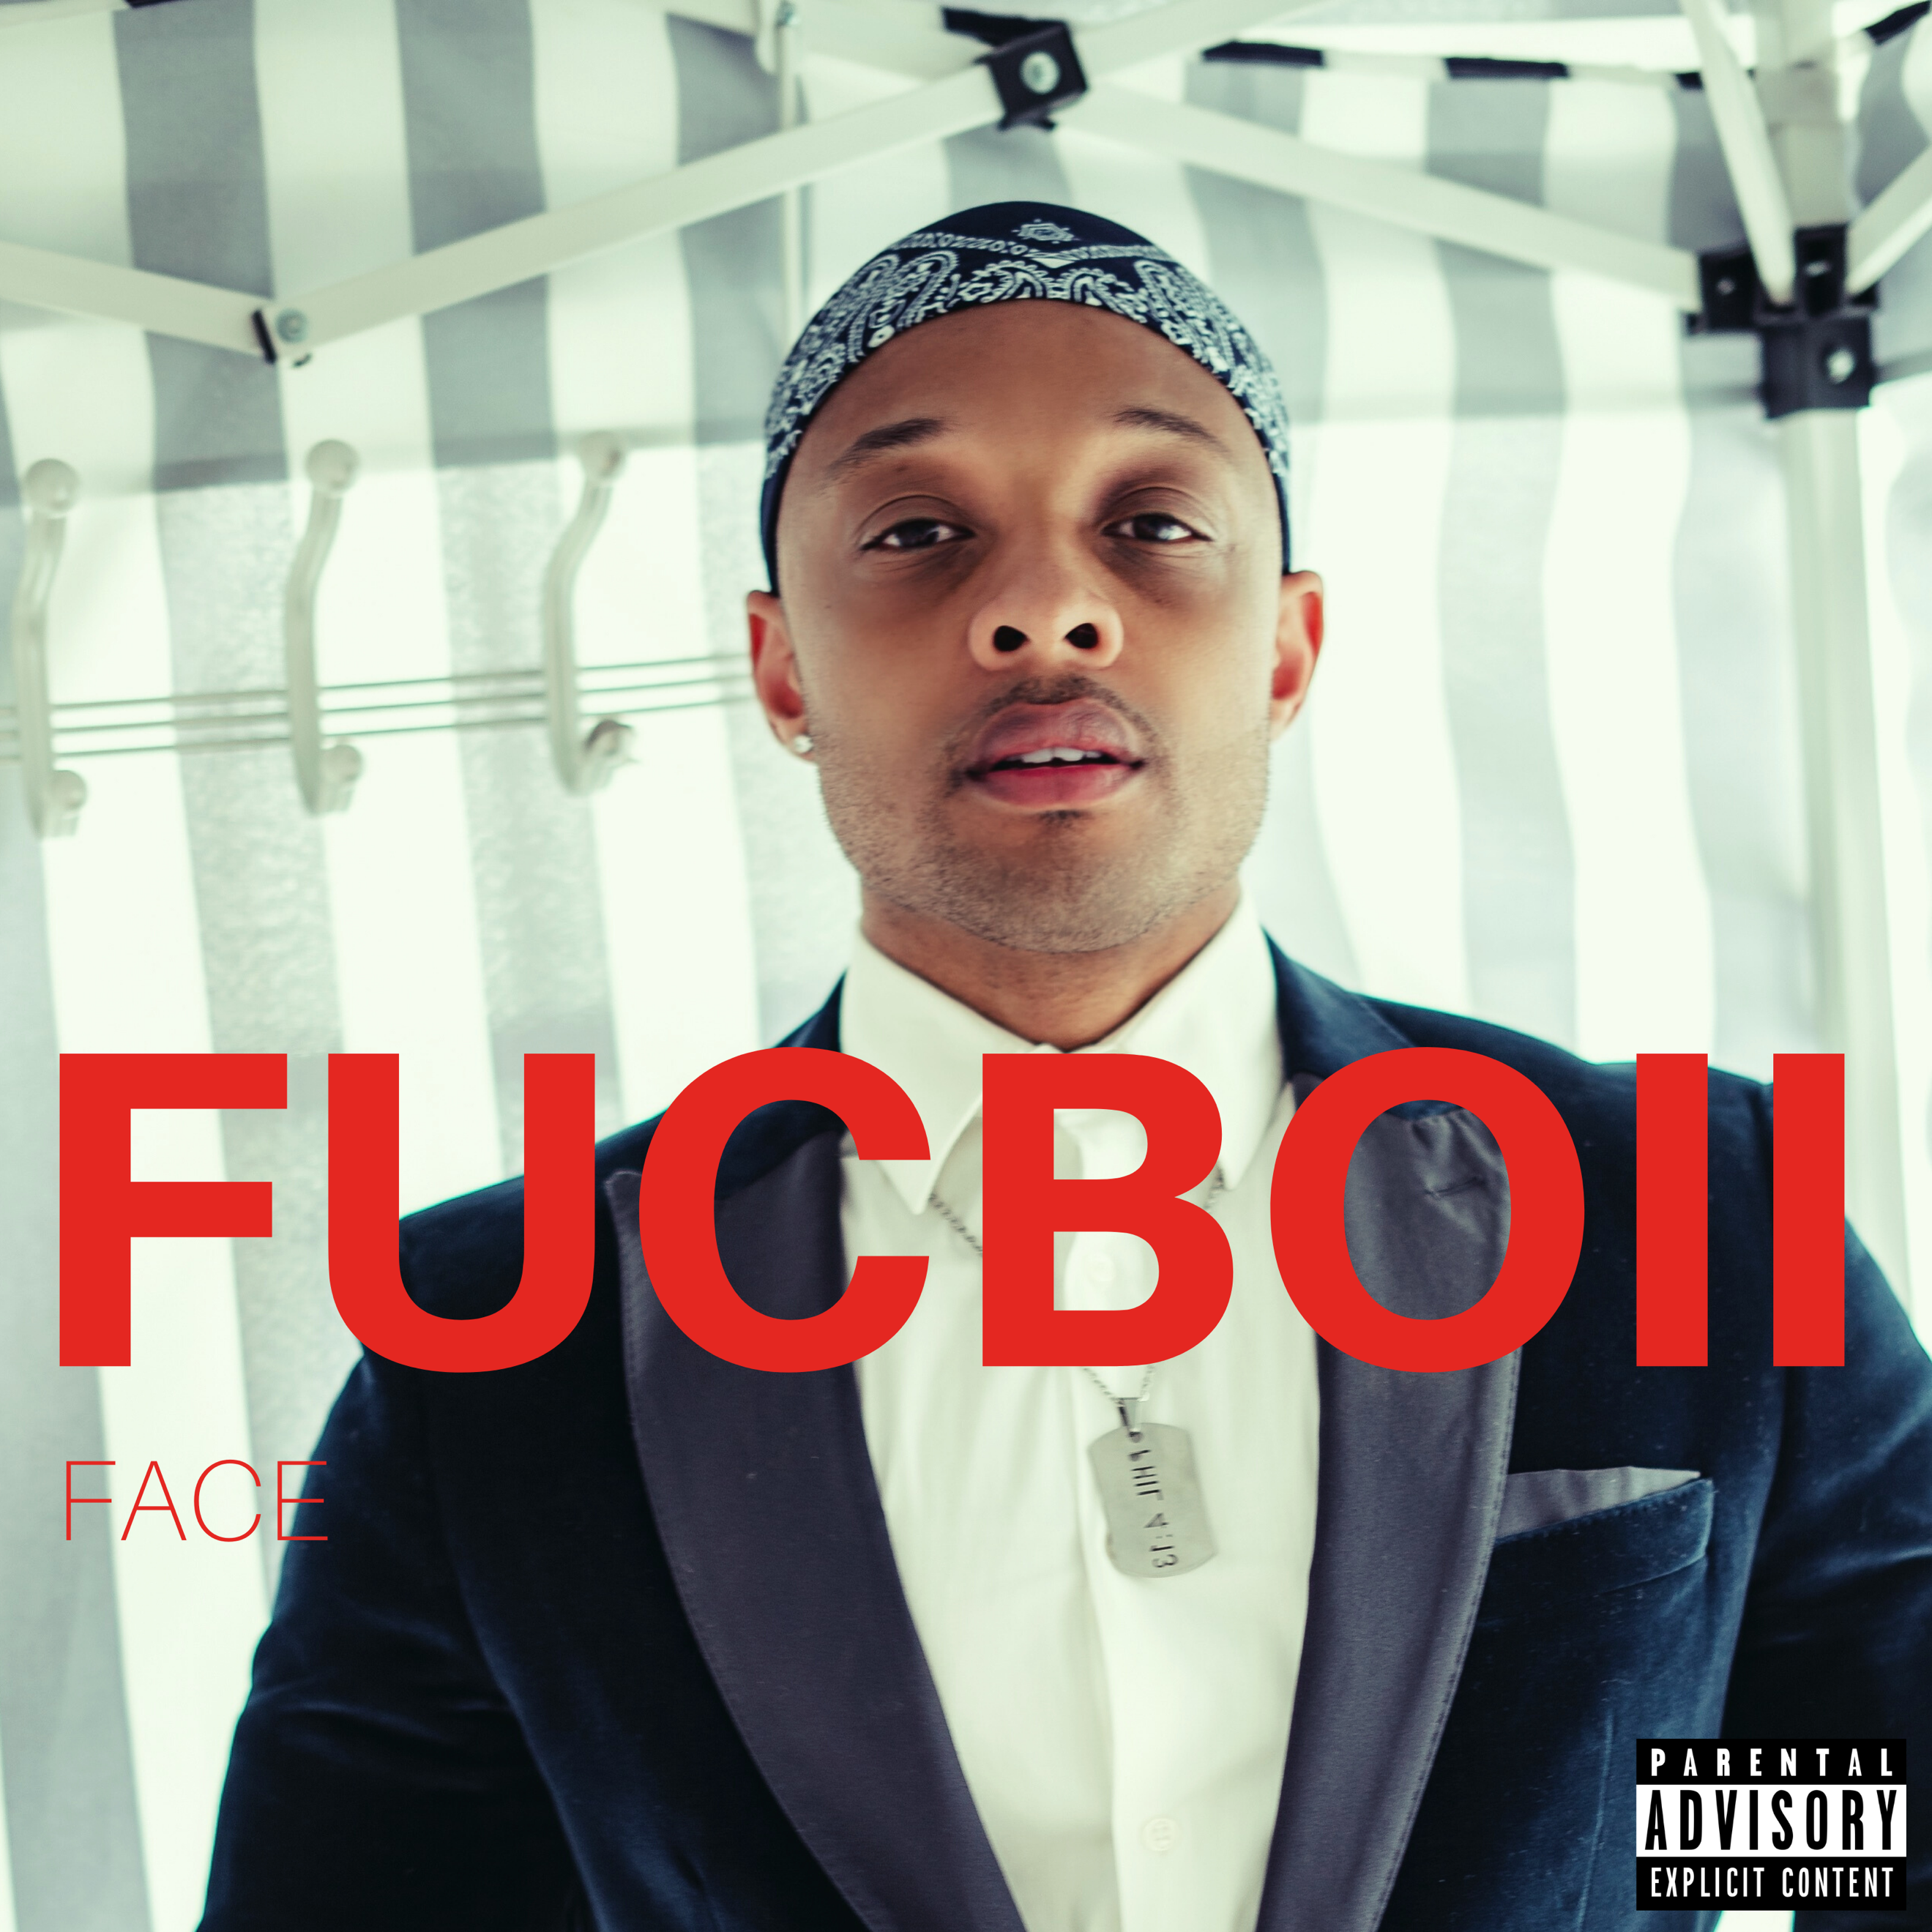
FACE will release his DEBUT SINGLE titled “FUCBOII” on March 13, 2020, on RUN THE PLAY ENTERTAINMENT. FACE, the Chicago bred singer/songwriter/rapper has teamed up with multi-platinum engineer/mixer Patrizio "Teezio" Pigliapoco (Chris Brown, Justin Bieber, Future, Young Thug) to emerges with raw, soulful energy that R&B fans live for.

Listen to “FUCBOII” HERE.

FACE stands at the threshold of a music career that will span for decades with the unprecedented critical acclaim he is poised to get from the release of “FUCBOII". He demonstrates an undeniable gift for songwriting and delivers silky smooth vocals that will put him on a trajectory to becoming an icon. “FUCBOII” is a catchy, sexy, mid-tempo R&B record with flawlessly smooth lyrics. Moody vibes, this sensual and provocative balled showcases his seductive voice and puts him in a class with R&B heavy hitters like Tank. While the title is provocative, the song is romantic with lyrics that are deep and impactful. “FUCBOII” will undoubtedly be the ladies anthem of the year!

Download media assets HERE
Music Video Sneak Peak: EDIT 1 (NOT FINAL) - FOR PREVIEW ONLY:
HERE
***

FACE, the Chicago bred multihyphenate singer/writer/rapper/ is ready to join the proud lineage of musical mavericks who have successfully toppled the music industry. FACE like so many of the greats before him—cultivated his voice singing in the church. As a young man, FACE, found inspiration from iconic voices in Gospel, R&B, and Hip-Hop like John P Kee, Usher, & Kanye West respectively. His vocal ability earned him two Grammy appearances singing background for R. Kelly & Madonna.
VIEW FULL BIO

For more information, please visit:
FACE
Website| Facebook | Twitter | Instagram | YouTube | Soundcloud

CONTACTS: GROWTH HACKER SOCIAL: MARKETING/ADVERTISING/PR
SUSAN COHEN 312-318-5876 susan.cohen@growthhackersocial.com

